**Lab-2**

**Distributed Systems**

**Suryanarayan.B**

**CB.EN.U4CSE19056**

1)

#include <mpi.h>

#include <stdio.h>

int main(int argc, char** argv) {

// Initialize the MPI environment

MPI_Init(NULL, NULL);

// Get the number of processes

int world_size;

MPI_Comm_size(MPI_COMM_WORLD, &world_size);

// Get the rank of the process

int world_rank;

MPI_Comm_rank(MPI_COMM_WORLD, &world_rank);

// Get the name of the processor

char processor_name[MPI_MAX_PROCESSOR_NAME];

int name_len;

MPI_Get_processor_name(processor_name, &name_len);

// Print off a hello world message

printf("Hello world from processor %s, rank %d out of %d processors\n",

processor_name, world_rank, world_size);

// Finalize the MPI environment.

MPI_Finalize();

}

Output:

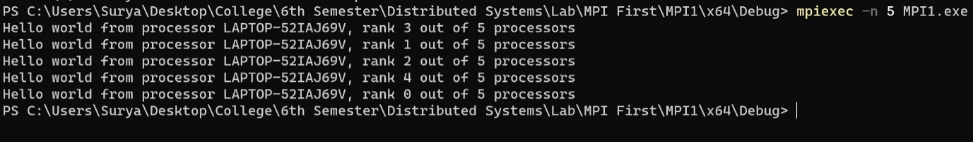

2)

#include <mpi.h>

#include <stdio.h>

int main() {

// Initialize the MPI environment

MPI_Init(NULL, NULL);

// Get the rank of the process

int world_rank;

MPI_Comm_rank(MPI_COMM_WORLD, &world_rank);

printf("\nProcess Rank: %d\n", world_rank);

// Finalize the MPI environment.

MPI_Finalize();

}

Output:

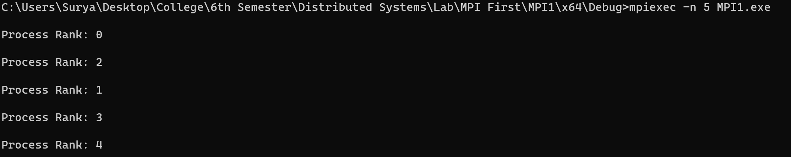

3)

#include <mpi.h>

#include <stdio.h>

int main(int argc, char** argv) {

int id, x,numpros,rootpros;

MPI_Status status;

x= MPI_Init(&argc, &argv);

x=MPI_Comm_size(MPI_COMM_WORLD, &numpros);

x=MPI_Comm_rank(MPI_COMM_WORLD, &id);

char processor_name[MPI_MAX_PROCESSOR_NAME];

int name_len;

MPI_Get_processor_name(processor_name, &name_len);

if (id == 0)

{

printf("Process 1 is working !!!!!!!");

}

else

{

printf("Other Process is working !!!!!!!!!!");

}

x=MPI_Finalize();

}

Output:

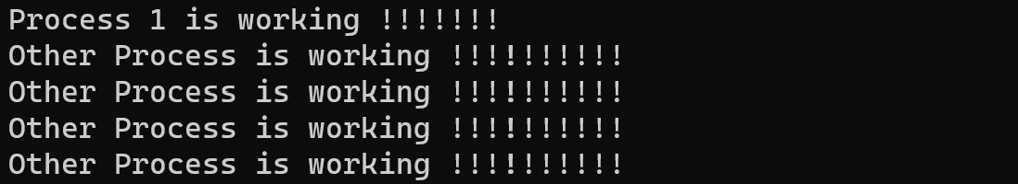

4)

#include <mpi.h>

#include <stdio.h>

#include<iostream>

using namespace std;

int main() {

int proc_id, num_processes, tag, src, dest, count;

int data;

// Initialize the MPI environment

MPI_Init(NULL, NULL);

// Get the number of processes

MPI_Comm_size(MPI_COMM_WORLD, &num_processes);

// Get the rank of the process / process id

MPI_Comm_rank(MPI_COMM_WORLD, &proc_id);

// Set up communication params

tag = 100;

// Process 0 is sender, Process 1 is receiver

src = 0;

dest = 1;

count = 1;

if (proc_id == src) {

data = 46920;

MPI_Send(&data, count, MPI_INT, dest, tag, MPI_COMM_WORLD);

cout<< "P_ID" << proc_id << " sent " << data <<"\n";

}

if (proc_id == dest) {

MPI_Recv(&data, count, MPI_INT, src, tag, MPI_COMM_WORLD, MPI_STATUS_IGNORE);

cout<< "P_ID" << proc_id << " received " << data << "\n";

}

MPI_Finalize();

return 0;

}

**Output:**



**5)**

#include <mpi.h>

#include <stdio.h>

#include<iostream>

using namespace std;

int main() {

int proc_id, num_processes, tag, src, dest, count;

int data, ack;

// Initialize the MPI environment

MPI_Init(NULL, NULL);

// Get the number of processes

MPI_Comm_size(MPI_COMM_WORLD, &num_processes);

// Get the rank of the process / process id

MPI_Comm_rank(MPI_COMM_WORLD, &proc_id);

// Set up communication params

tag = 100;

// Process 0 is sender, Process 1 is receiver

src = 0;

dest = 1;

count = 1;

if (proc_id == src) {

data = 475638;

MPI_Send(&data, count, MPI_INT, dest, tag, MPI_COMM_WORLD);

cout << "Sender: P_ID" << proc_id << " sent " << data << "\n";

MPI_Recv(&ack, count, MPI_INT, dest, tag, MPI_COMM_WORLD, MPI_STATUS_IGNORE);

if (ack == 1) {

cout << "Sender: Ack received from receiver : "<< ack << "\n";

}

}

if (proc_id == dest) {

MPI_Recv(&data, count, MPI_INT, src, tag, MPI_COMM_WORLD, MPI_STATUS_IGNORE);

cout << "Receiver: P_ID" << proc_id << " received " << data << "\n";

ack = 1;

MPI_Send(&ack, count, MPI_INT, src, tag, MPI_COMM_WORLD);

cout << "Receiver: P_ID" << proc_id << " sent " << ack << "\n";

}

MPI_Finalize();

return 0;

}

**Output:**



**6)**

#include <mpi.h>

#include <stdio.h>

#include<iostream>

using namespace std;

int main(int argc, char** argv) {

MPI_Init(&argc, &argv);

int world_size;

MPI_Comm_size(MPI_COMM_WORLD, &world_size);

int world_rank;

MPI_Comm_rank(MPI_COMM_WORLD, &world_rank);

char processor_name[MPI_MAX_PROCESSOR_NAME];

int name_len;

MPI_Get_processor_name(processor_name, &name_len);

if (world_rank == 0) {

int ack = 0;

MPI_Recv(

&ack,

1,

MPI_INT,

1,

0,

MPI_COMM_WORLD,

MPI_STATUS_IGNORE

);

cout << "deadlock in root";

}

else {

int ack = 0;

MPI_Recv(

&ack,

1,

MPI_INT,

0,

0,

MPI_COMM_WORLD,

MPI_STATUS_IGNORE

);

cout << "deadlock in child";

}

MPI_Finalize();

}

**Output:**



**Deadlock**